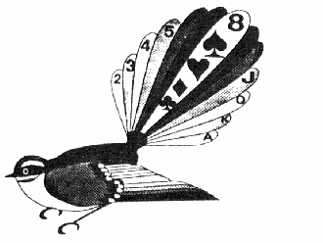 | Taradale Bridge Club
Lodge Omarunui
8 Elbourne Street, Taradale
CHRISTMAS PARTY

SUNDAY 6 DECEMBER 2020

Drinks at 11:30 am
Lunch 12:00 noon
RSA 156 Gloucester Street, Taradale

Bridge 1:30 pm (no charge)
Lodge Omarunui, 8 Elbourne St, Taradale

Lunch bookings close
Monday, 30 November 2020
On the day sales not available

Lunch tickets available from a Convenor
$22.00
OR
Payment online 03-0631-0174234-00

State name in Particulars field and Xmas in Reference field

